Limestone Middle School

Make Today Matter

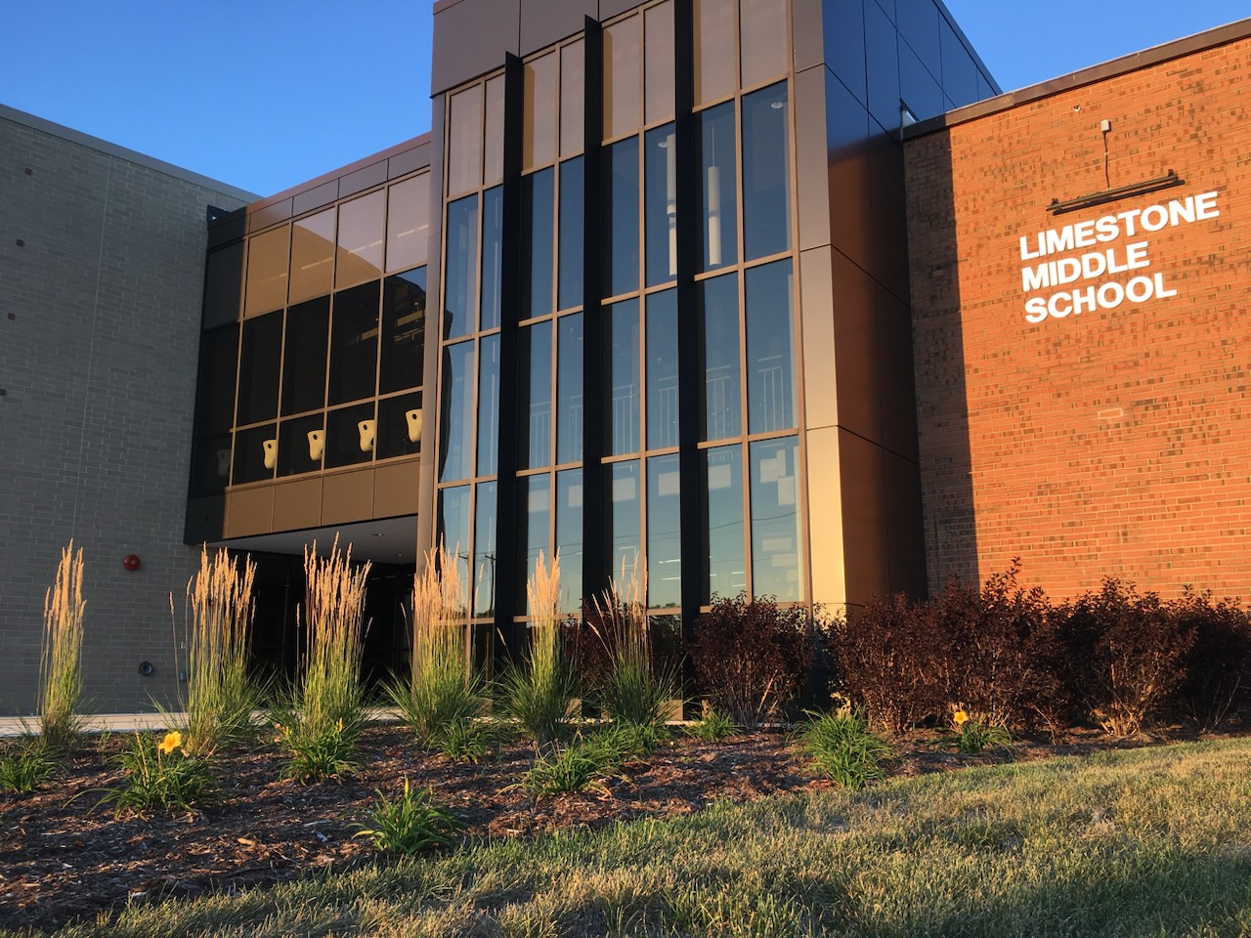

**____________________________________________________________________________________________**

**SEL School-wide November Theme:**

BE KIND! *There is never enough nice.*

**STUDENT LIFE**

**Book Fair**

Thank you to all the students and parents who came out to the LMS Book Fair. We appreciate Tricia Coffman leading this school-wide opportunity to partner with Scholastic in putting books into students’ hands. Our PTA generously purchased a book for every middle school student during this year’s event. Many of our parents and guests purchased a classroom book for our teacher’s class libraries as well. We are fortunate to have such a wonderful school community.

**Red Ribbon Week**

The Limestone SEL: Students Empowered 4 Life Student Leaders decorated our school with Red Ribbons and sponsored spirit week activities including daily positive school-wide messaging. This year’s theme was “Be kind to your mind.”

**Grade 6 Fall Concert**

Grade 6 musicians performed the first concert of the year for parents and family members. Thanks to Ms. Cessna, Ms. Griffin and Ms. Edmonds for preparing the orchestra, band and chorus students.

**Tiger Girls Basketball**

Congratulations to the Grade 8 Girls’ Basketball Team and Coach Dana Brychta on their 3rd place finish in the Kan-Will Conference Tournament played on their home court.

**Tiger Cross Country**

Great job to our boys’ cross country team and Layla K and Kendahl O who qualified at sectionals and represented LMS well at the IESA State XC Meet.

**Speech Team**

Our speech team participated in the IESA Speech Contest and received “Best of Day” awards in duet acting, group acting and team improv. Congratulations!

**Honoring Veteran’s Day**

LMS Student Council members led school-wide recognitions for Veteran’s Day including spirit days, a school-wide letter writing initiative and a fundraising campaign “Change War” for Project Headspace. Some Social Science teachers hosted guest presenters and student activities recognized the holiday and its importance in our country.

In addition to the above information items, we remind and encourage you to follow us on Facebook for regularly posted images and information about our students and our school.

Submitted by: Ms. Michelle Chavers, Principal